|  |
| --- |
| SRM Institute of Science and Technology Faculty of Engineering and Technology  Department of Electronics and Communication Engineering |
| **18ECC303J COMPUTER COMMUNICATION NETWORKS**  **COMMUNICATION Sixth Semester, 2021-22 (even semester)** |

**Mini Project Report**

**Name : PALLA SAI ANEESH**

**Register No. : RA1911004010666**

**Day / Session : 2/FN**

**Venue : TP 1118 NETWORKING LAB**

**Project Title : IoT based smart Home using WPA2 security & Radius server in Cisco Packet**

**Tracer**

|  |  |
| --- | --- |
| **Lab Supervisor** | **:** |
| **Team Members** | **: PALLA SAI ANEESH (RA1911004010666)**  **SIVA ANAND**  **(RA1911004010663)**  **POLA YASWANTH REDDY**  **(RA1911004010658)** |

**REPORT VERIFICATION: MR. PRAVEEN KUMAR**

**Date :**

**Staff Name : MR . PRAVEEN KUMAR**

# IoT based smart Home using WPA2 security & Radius server in Cisco Packet Tracer

**Objective:**

To create a IOT based smart house using WPA2 security and Radius server.

# Abstract:

IOT home automation is the ability to control domestic appliances by electronically controlled, internet-connected systems. It may include setting complex heating and lighting systems in advance and setting alarms and home security controls, all connected by a central hub and remote-controlled by a web link or mobile app.

**Introduction:**

The Internet of Things (IOT) is a system of interrelated computing devices, mechanical and digital machines, objects, animals or people that are provided with unique identifiers and the ability to transfer data over a network without requiring human-to-human or human-to-computer interaction.Control and Monitoring the IOT significantly improves the way you can control and monitor all the processes taking place at your home. Like the example of fridge can notify you if your yogurt gets spoiled in two days or can add milk into the shopping list.

**Sofware Requirements:**

Cisco Packet tracer was used with the instruments of 1)IOT & Radius server

2)Switch 3)Router 4)Fan 5)Garage Door

6)Light 7)Door 8)Window

9)Operating client device(Laptop)

**Working Principle:**

IOT works by connecting items and then having the ability to sense and communicate. This leads the devices to communicate or interact with other devices and with the human.

# Procedure;

To create IOT based smart house in CISCO packet tracer

1. In CISCO packet tracer we have to create network for our house hold devices to connect with the serve.
2. For creating network we have to connect specific adapters to house hold devices which represents their IP address.
3. All this devices are connected to a router in the network to connect with switch which was connected to a server and the client device.
4. With in the help of switch in the network which was connected to server with all the IP addresses of house hold devices we creating a access portal for the client to access his/her households from their device.
5. By entering their user credentials in the provided client web or app for their IP address which was hold in server they are able to control their house hold

# Controlling of IOT based smart house using WPA2 security and Radius server in CISCO packet:

# 

# 

**Status of Difference between On and Offing of all devices in IOT based smart Home:**

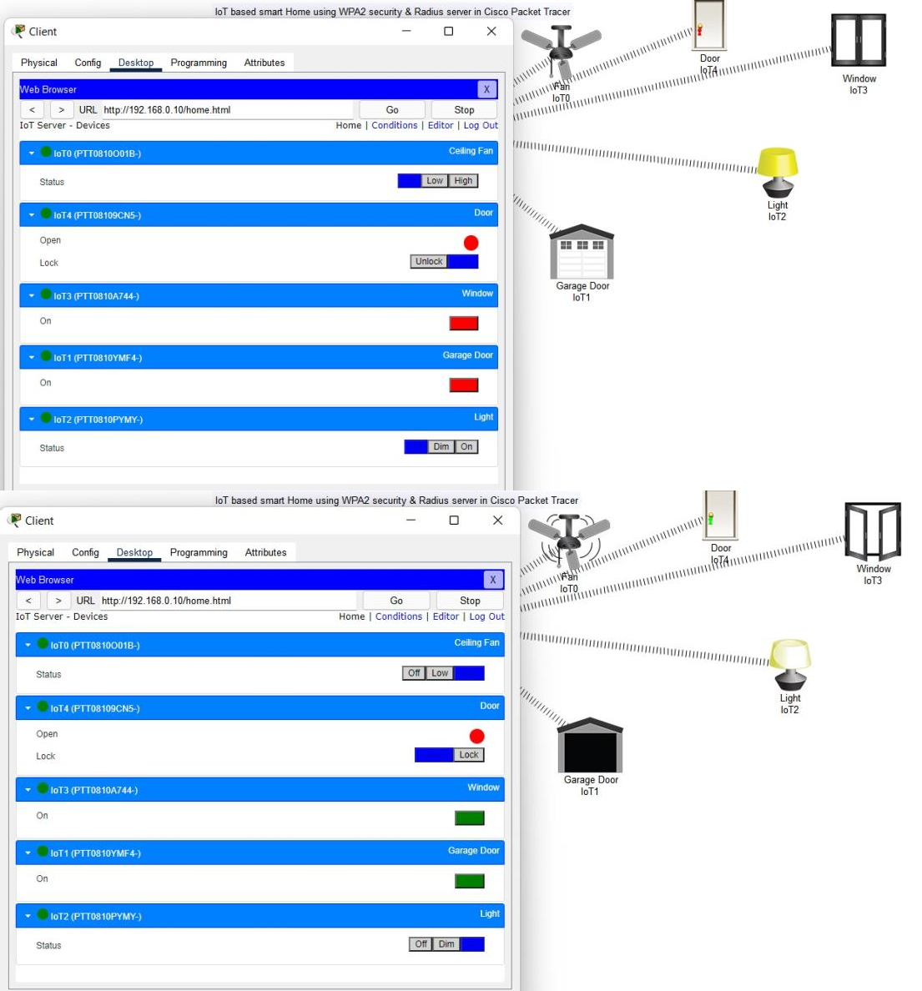

# Result:

Designing of IOT based smart home using WPA2 & Radius server in CISCO packet tracer was successfully completed.